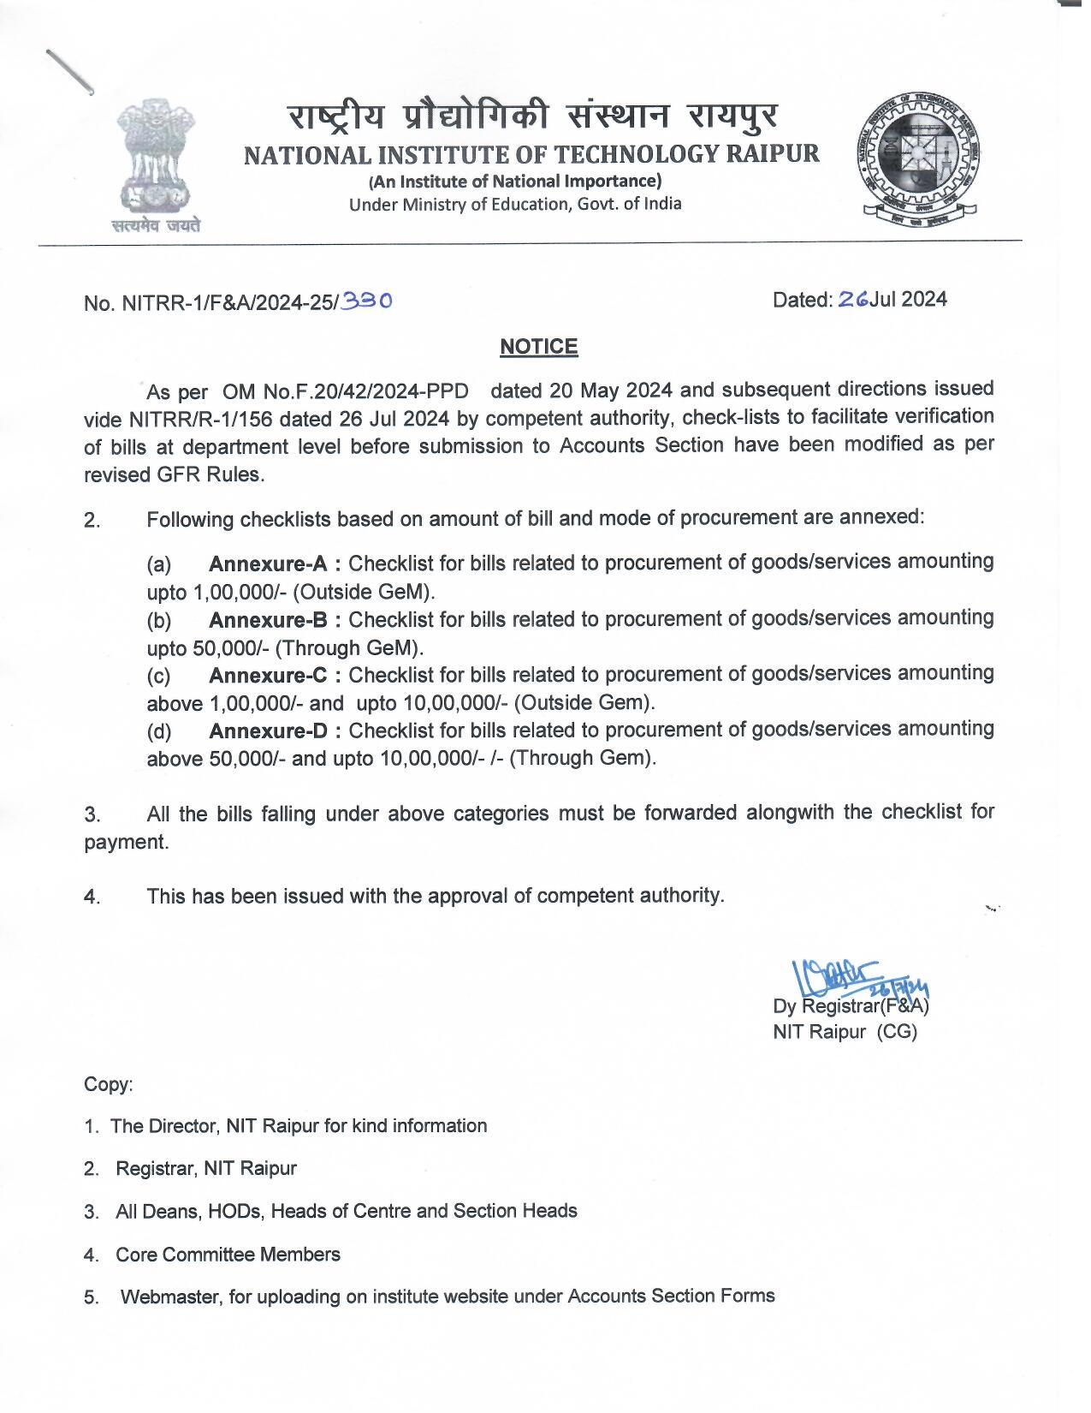

**Annexure-A**

**CHECKLIST FOR PROCUREMENT BILLS AMOUNTING**

**UPTO Rs. 1,00,000/-**

**(OUTSIDE of GeM)**

|  |  |  |  |
| --- | --- | --- | --- |
| **Sl No** | **Details of Document/Certificate** | **Enclosed (Yes/No)** | **Page No** |
| 1. | Fully Vouched Contigent (FVC) bill duly filled and signed by intender & HOD/Section Head |  |  |
| 2. | Original Tax Invoice/Bill of supply (GST No. of NIT Raipur i.e **22AAAJN0643G1ZN** must be mentioned on the bill) |  |  |
| 3. | Original Financial & Administrative approval of Competent Authority for current FY |  |  |
| 4. | GST Registration details of Vendor |  |  |
| 5. | Proper Bank Details of Vendor |  |  |
| 6. | Acceptance certificate & Stock entry certificate by concerned department/section **on the back side** of Tax Invoice/Bill |  |  |
| 7. | Duly signed certificate by competent authority for purchase of goods valuing upto Rs.1,00,000/- without quotation as per Rule 154 of GFR & Notice No.NITRR/F&A/2017-18/9883 dated 18 May 2017 |  |  |
| 8. | Stock Entry certificate on the back side of Tax Invoice/Bill by Centralized Stores & Purchase department (Authy: Rule 208 of GFR & Order No.NITTR/R-1/2016/128 dated 21 Apr 2016) |  |  |
| 9. | GeMAR&PTS Report for non availability on GeM **(on or before purchase date)** |  |  |
| 10. | Warranty Certificate from **date of installation** (duly counter-signed by HOD/PI/Intender) |  |  |
| 11. | Delivery Challan (duly counter-signed by HOD/PI/Intender) |  |  |
| 12. | Installation Report for equipments/instruments (duly counter-signed by HOD/PI/Intender) |  |  |

Signature of HOD/PI/Section Head

Dy. Registrar (S&P)/ Dy. Registrar (F&A)

**Annexure-B**

**CHECKLIST FOR PROCUREMENT BILLS AMOUNTING**

**UPTO Rs. 50,000/-**

**(THROUGH GeM)**

|  |  |  |  |
| --- | --- | --- | --- |
| **Sl No** | **Details of Document/Certificate** | **Enclosed (Yes/No)** | **Page No** |
| 1. | Fully Vouched Contigent (FVC) bill duly filled and signed by intender & HOD/Section Head |  |  |
| 2. | Original Tax Invoice/Bill of supply (GST No. of NIT Raipur i.e **22AAAJN0643G1ZN** must be mentioned on bill) |  |  |
| 3. | Original Financial & Administrative approval of Competent Authority for current FY |  |  |
| 4. | GST Registration details of Vendor |  |  |
| 5. | Proper Bank Details of Vendor |  |  |
| 6. | Acceptance certificate & Stock entry certificate by concerned department/section on the back side of Tax Invoice/Bill |  |  |
| 7. | Stock Entry certificate on the back side of Tax Invoice/Bill by Centralized Stores & Purchase department (Authy: Rule 208 of GFR & Order No.NITTR/R-1/2016/128 dated 21 Apr 2016) |  |  |
| 8. | GeM Invoice |  |  |
| 9. | Gem Contract |  |  |
| 10. | Consignee Receipt & Acceptance Certificate (CRAC) |  |  |
| 11. | Warranty Certificate from **date of installation** (duly counter-signed by HOD/PI/Intender) |  |  |
| 12. | Delivery Challan (duly counter-signed by HOD/PI/Intender) |  |  |
| 13. | Installation Report for equipments/instruments (duly counter-signed by HOD/PI/Intender) |  |  |

Signature of HOD/PI/Section Head

Dy. Registrar (S&P)/ Dy. Registrar (F&A)

**Annexure-C**

**CHECKLIST FOR PROCUREMENT BILLS AMOUNTING**

**MORE THAN Rs. 1,00,000/- and UPTO 10,00,000/-**

**(OUTSIDE OF GeM)**

|  |  |  |  |
| --- | --- | --- | --- |
| **Sl No** | **Details of Document/Certificate** | **Enclosed (Yes/No)** | **Page No** |
| 1. | Fully Vouched Contigent (FVC) bill duly filled and signed by intender & HOD/Section Head |  |  |
| 2. | Original Tax Invoice/Bill of supply as per **PO/WO** (GST No. of NIT Raipur i.e **22AAAJN0643G1ZN** must be mentioned on bill) |  |  |
| 3. | Original Financial & Administrative approval of Competent Authority for current FY |  |  |
| 4. | GST Registration details of Vendor |  |  |
| 5. | Proper Bank Details of Vendor |  |  |
| 6. | Purchase/Work Order Copy |  |  |
| 7. | Minimum 03 Vendor Comparative Statement and other related documents duly signed by DPC members |  |  |
| 8. | Pre-audit copy |  |  |
| 6. | Acceptance certificate & Stock entry certificate by concerned department/section on the back side of Tax Invoice/Bill |  |  |
| 8. | Stock Entry certificate on the back side of Tax Invoice/Bill by Centralized Stores & Purchase department (Authy: Rule 208 of GFR & Order No.NITTR/R-1/2016/128 dated 21 Apr 2016) |  |  |
| 9. | GeMAR&PTS Report for non availability on GeM **( before PO/WO date)** |  |  |
| 10. | Warranty Certificate as per **PO** from **date of installation** (duly counter-signed by HOD/PI/Intender) |  |  |
| 11. | Delivery Challan (duly counter-signed by HOD/PI/Intender)  (**E-way** bill in case of bill amounting **more than 50,000/-**) |  |  |
| 12. | Installation Report for equipments/instruments (In case of Computer items Belarc or similar report), duly counter-signed by HOD/PI/Intender |  |  |
| 13. | Performance Bank Gaurantee as per **PO/WO** |  |  |

Signature of HOD/PI/Section Head

Dy. Registrar (S&P)/ Dy. Registrar (F&A)

**Annexure-D**

**CHECKLIST FOR PROCUREMENT BILLS AMOUNTING**

**MORE THAN Rs. 50,000/- and UPTO 10,00,000/-**

**(Through GeM)**

|  |  |  |  |
| --- | --- | --- | --- |
| **Sl No** | **Details of Document/Certificate** | **Enclosed (Yes/No)** | **Page No** |
| 1. | Fully Vouched Contigent (FVC) bill duly filled and signed by intender & HOD/Section Head |  |  |
| 2. | Original Tax Invoice/Bill of supply as per **PO/WO** (GST No. of NIT Raipur i.e **22AAAJN0643G1ZN** must be mentioned on bill) |  |  |
| 3. | Original Financial & Administrative approval of Competent Authority for current FY |  |  |
| 4. | GST Registration details of Vendor |  |  |
| 5. | Proper Bank Details of Vendor |  |  |
| 6. | GeM Contract |  |  |
| 7. | GeM generated Comparative Statement and other related documents duly signed by DPC members |  |  |
| 8. | GeM Invoice |  |  |
| 6. | Acceptance certificate & Stock entry certificate by concerned department/section on the back side of Tax Invoice/Bill |  |  |
| 8. | Stock Entry certificate on the back side of Tax Invoice/Bill by Centralized Stores & Purchase department (Authy: Rule 208 of GFR & Order No.NITTR/R-1/2016/128 dated 21 Apr 2016) |  |  |
| 9. | Consignee Receipt & Acceptance Certificate (CRAC) |  |  |
| 10. | Warranty Certificate as per GeM Contract from **date of installation** (duly counter-signed by HOD/PI/Intender) |  |  |
| 11. | Delivery Challan (duly counter-signed by HOD/PI/Intender)  (**E-way** bill in case of bill amounting **more than 50,000/-**) |  |  |
| 12. | Installation Report for equipments/instruments (In case of Computer items Belarc or similar report), duly counter-signed by HOD/PI/Intender |  |  |
| 13. | Performance Bank Gaurantee as per GeM Contract |  |  |

Signature of HOD/PI/Section Head

Dy. Registrar (S&P)/ Dy. Registrar (F&A)