National Institute of Technology Raipur
Department of Chemistry

Laboratory Facilities
The Department of Chemistry is equipped with well-organized laboratories supporting both academic instruction and research activities.
For B.Tech. Students
- Applied Chemistry Laboratory (1st & 2nd Semester)
- Environment and Ecology Laboratory (1st & 2nd Semester)
For M.Sc. Chemistry Students
- Chemistry Laboratory (1st & 2nd Year)
These laboratories provide essential practical exposure aligned with theoretical courses.

Research Laboratory
A dedicated research facility supports advanced investigations and includes:
- UV-Visible Spectrophotometer
- Atomic Absorption Spectrophotometer
- Fluorescence Spectrophotometer
- Potentiometer
- Rheometer
- Millipore Water Purifier

Applied Chemistry Laboratory
List of Experiments:

- Determination of percentage composition of a mixture of Sodium Hydroxide and Sodium Chloride.
- Determination of the type and extent of alkalinity of given water sample.
- Redox titration using Potassium Permanganate and Potassium Dichromate as oxidizing agents.
- Determination of hardness of given water sample by complexometric titration.
- Determination of Ca and Mg hardness of given water sample.
- Determination of Chloride Ion by Argentometric titration-Mohr’s method.
- Determination of Calorific Value of fuel by Bomb Calorimeter.
- Determination of Flash Point and Fire Point of lubricant by Pensky Martin apparatus.
- Synthesis of Bakelite.
- Flue Gas analysis by Orsat’s apparatus.
Environment and Ecology Laboratory
List of Experiments:
- Determination of free CO2 in a given water sample.
- Determination of acidity of given sample of water.
- Determination of free residual chlorine present in given water sample.
- Determination of hardness of water sample.
- Determination of Dissolved Oxygen present in given water sample.
- Determination of Chemical Oxygen Demand in waste water sample.
- Measurement of pH of the given water sample.
- Determination of sulphate in the given water sample.
- Determination of sodium and potassium in the given water sample by Flame Photometer.
- Measurement of Turbidity of given water sample by Nephelo-Tubidity meter.
Equipment Available in B.Tech. Laboratory
Name of Equipment | Photo | Is Working?
B.Tech. Laboratory | 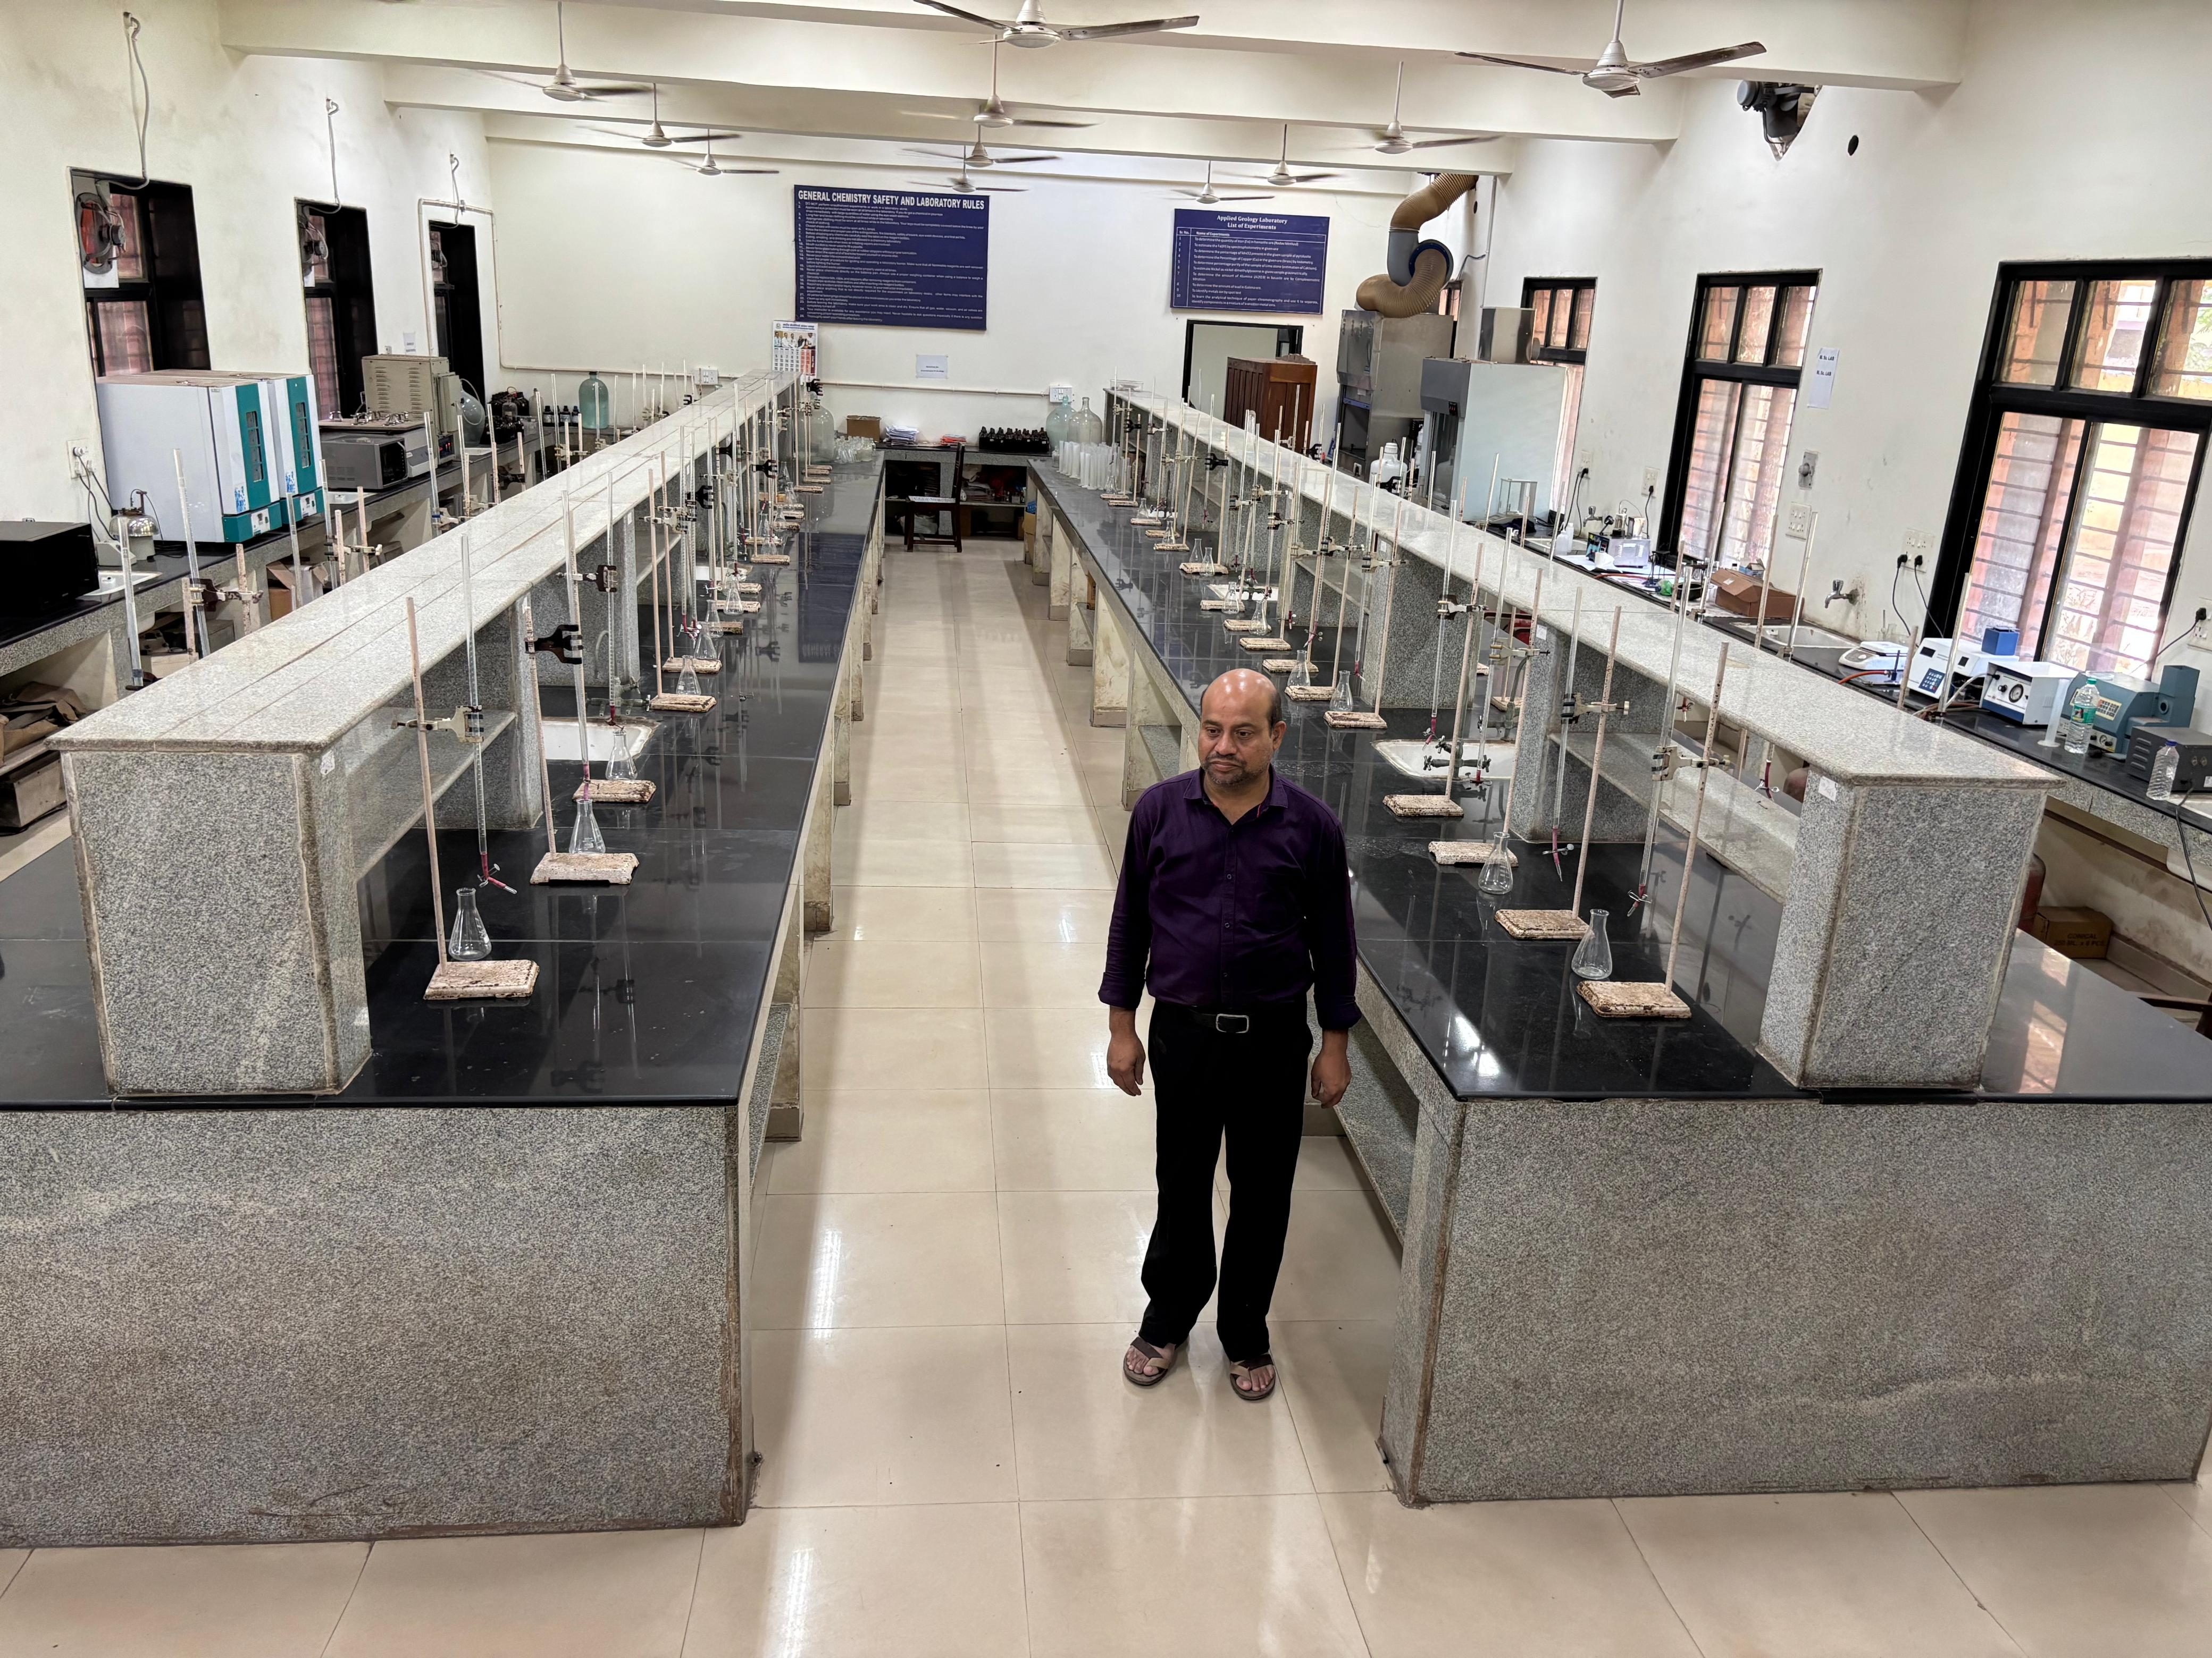 | Yes
pH Meter | 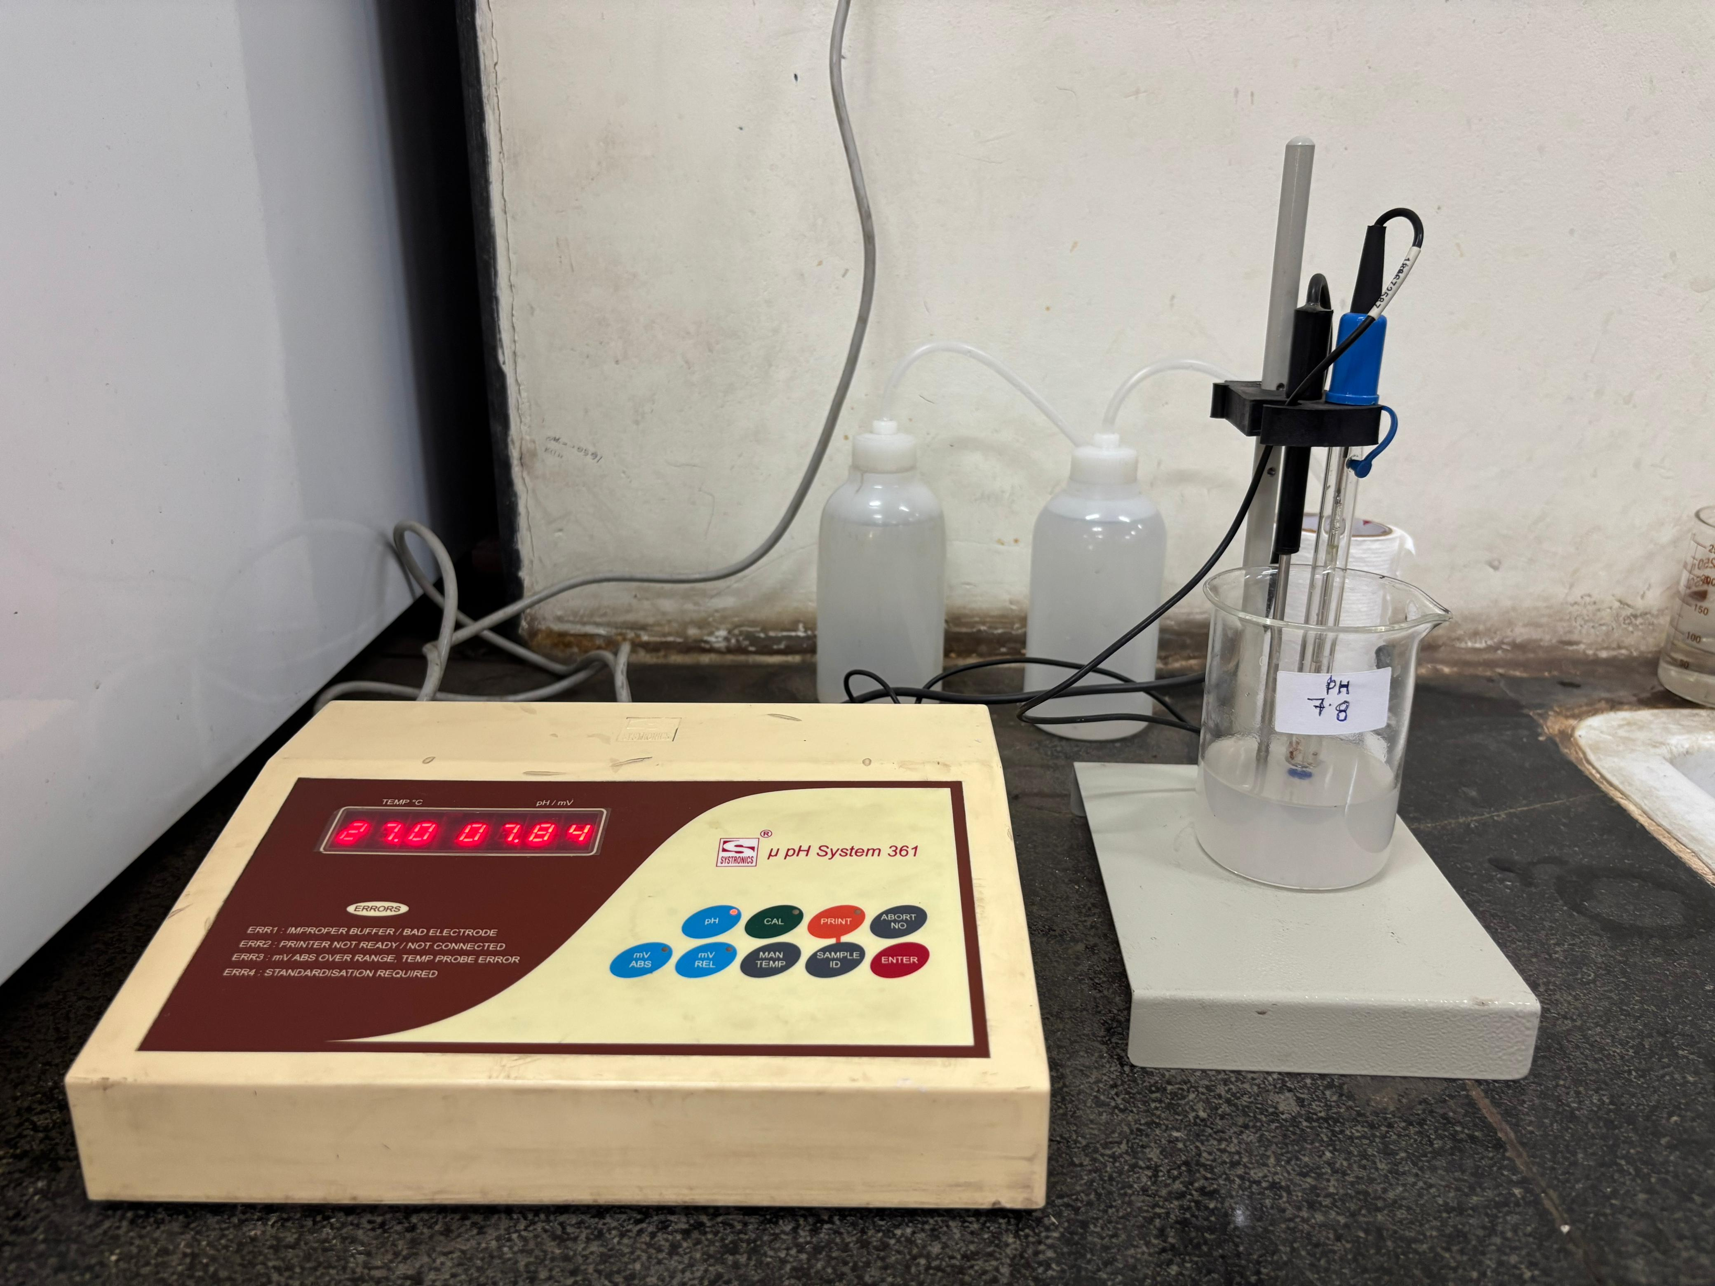 | Yes
Turbidity meter | 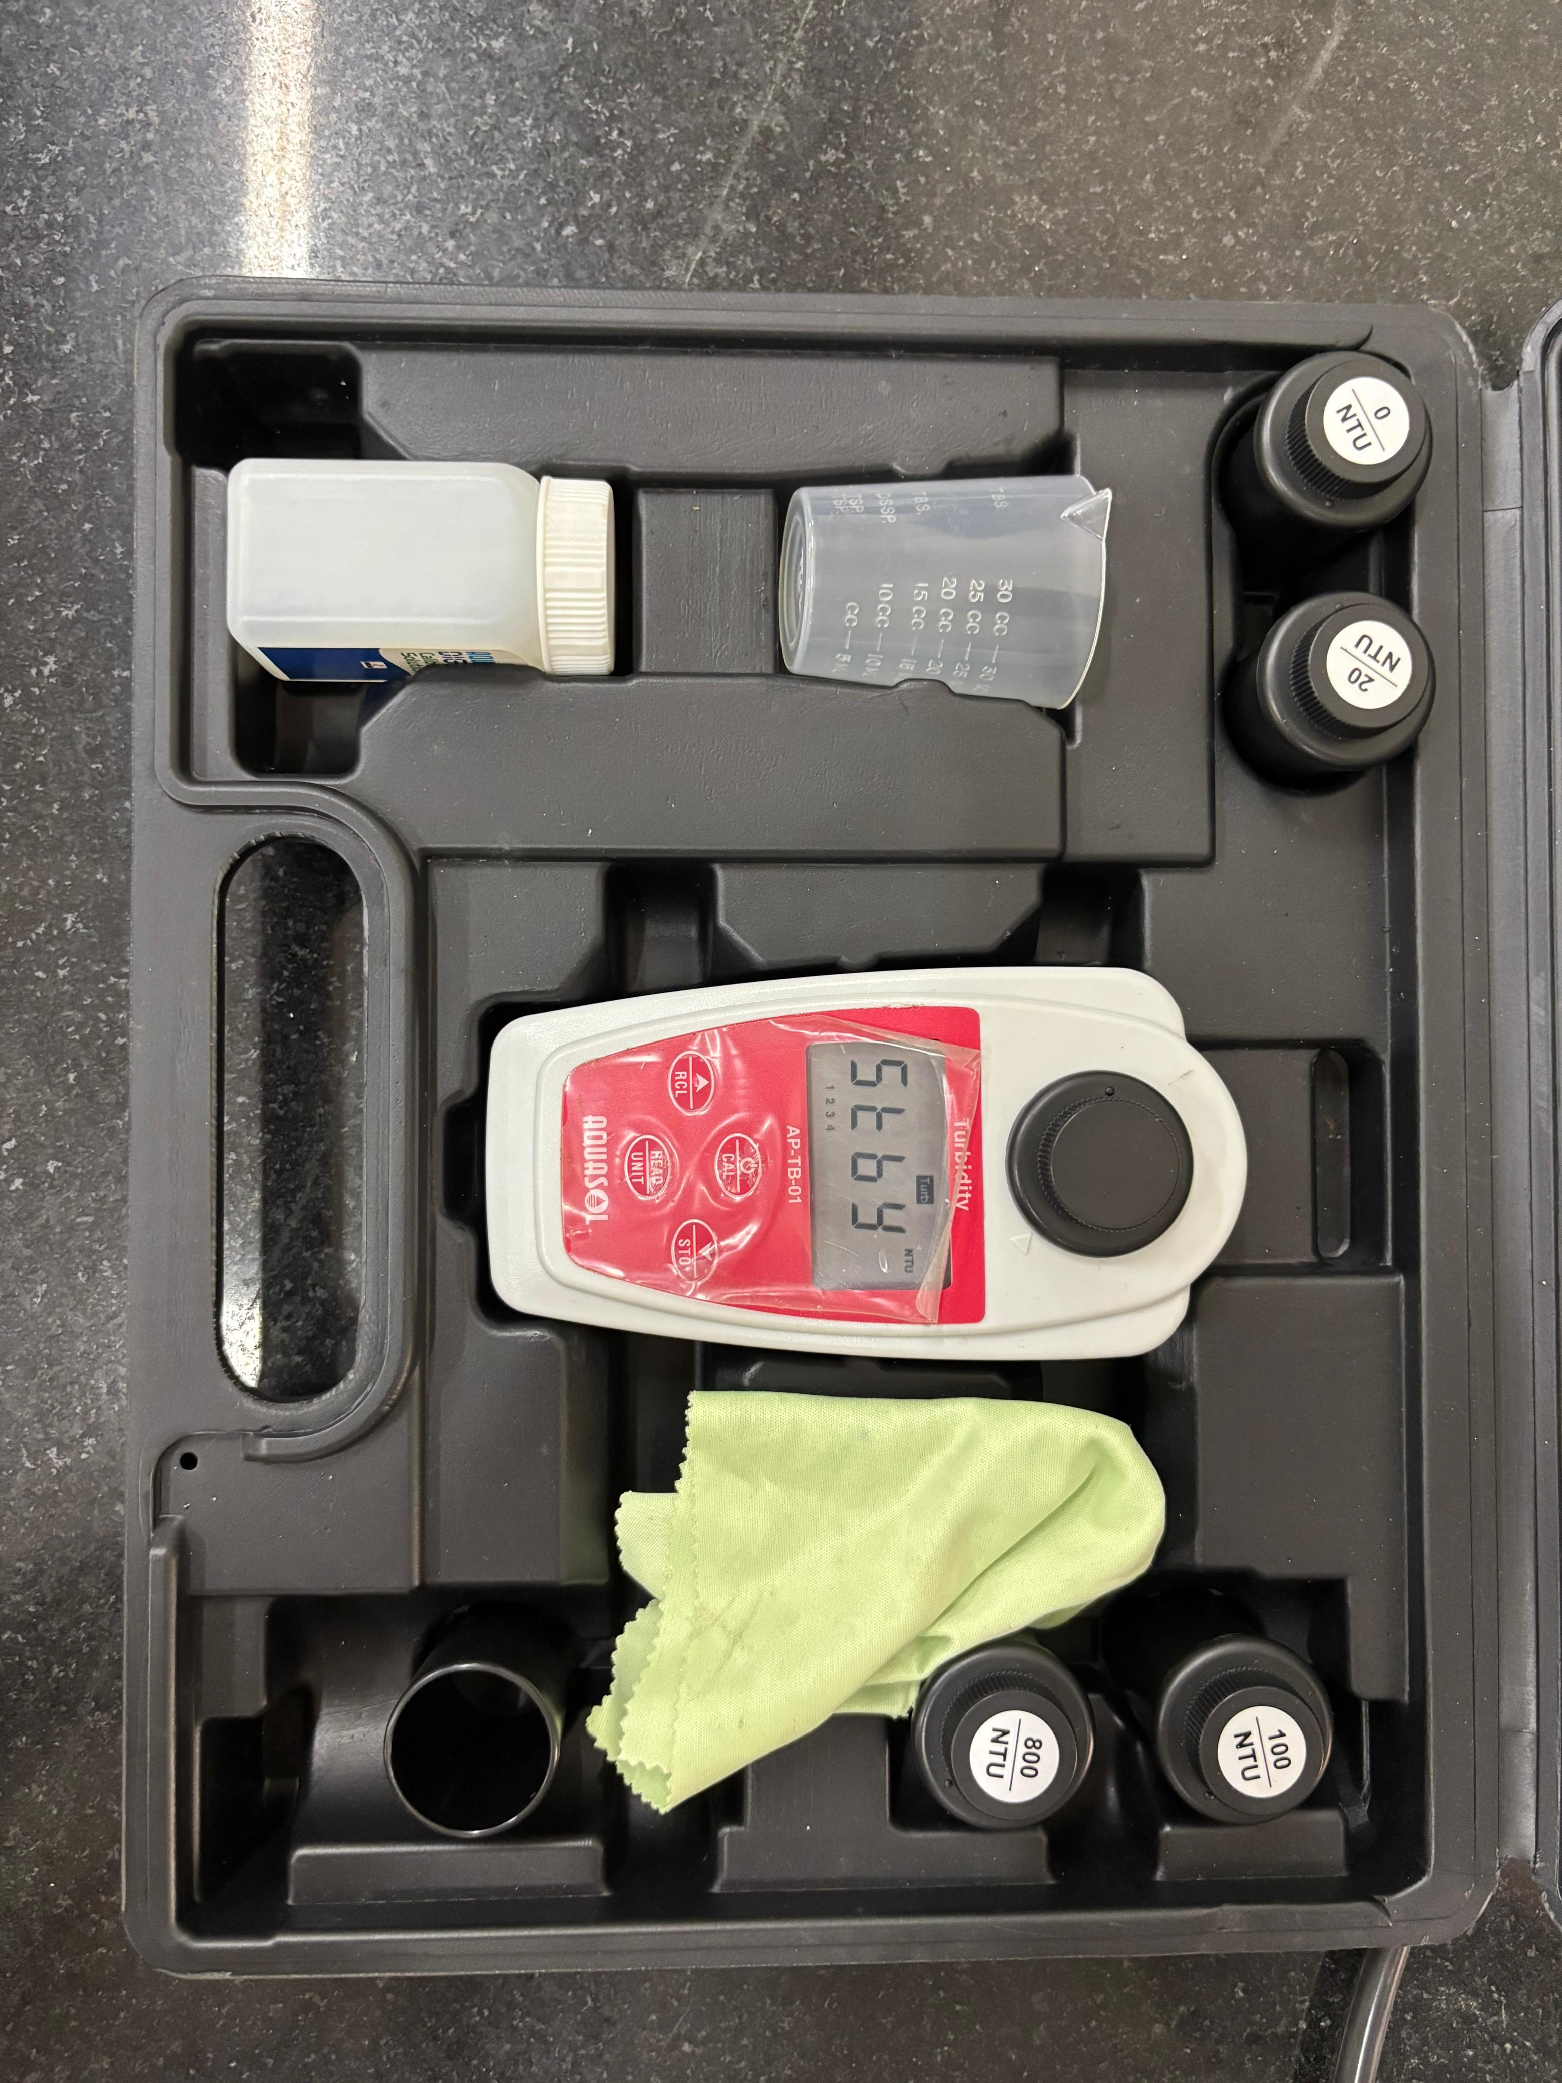 | Yes
Pensky-Merten Apparatus | 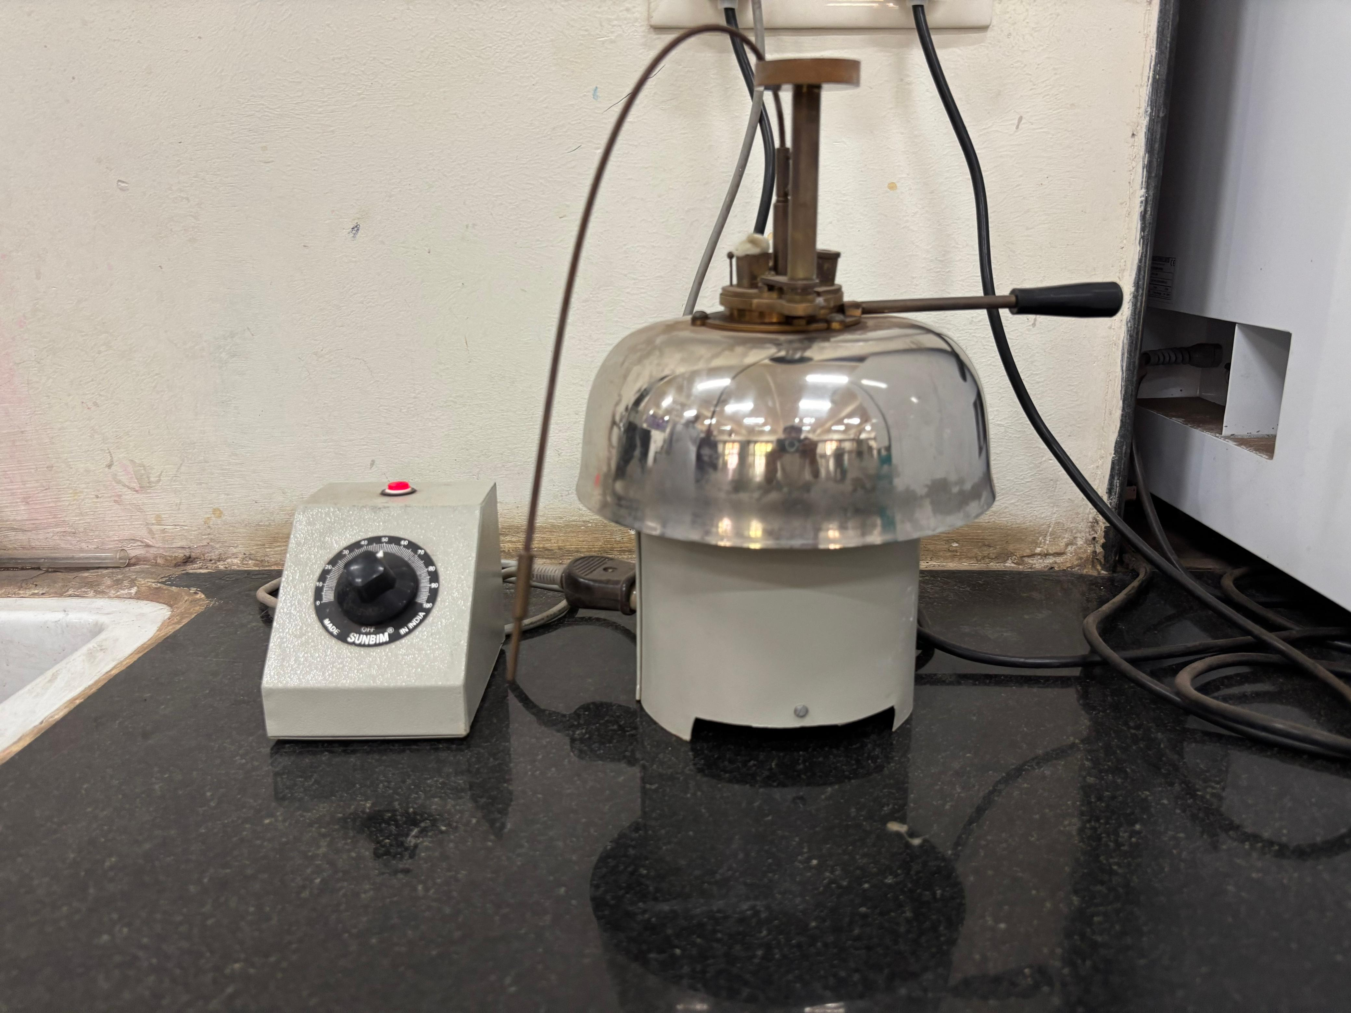 | Yes

Equipment Available in M.Sc. Chemistry Laboratory
Name of Equipment | Photo | Is Working?
Conductivity Meter | 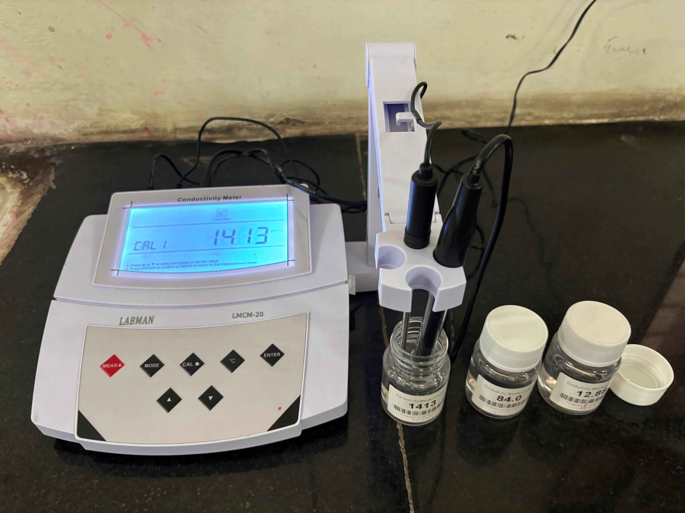 | Yes
Fluorescence Spectrophotometer | 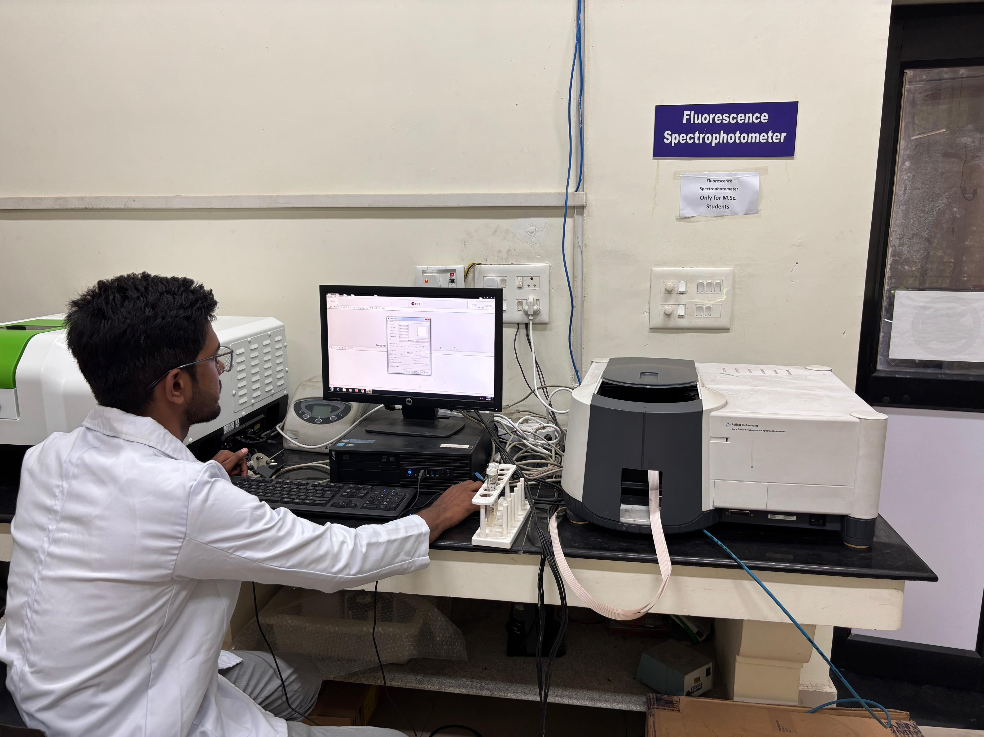
Digital Melting Point Apparatus | 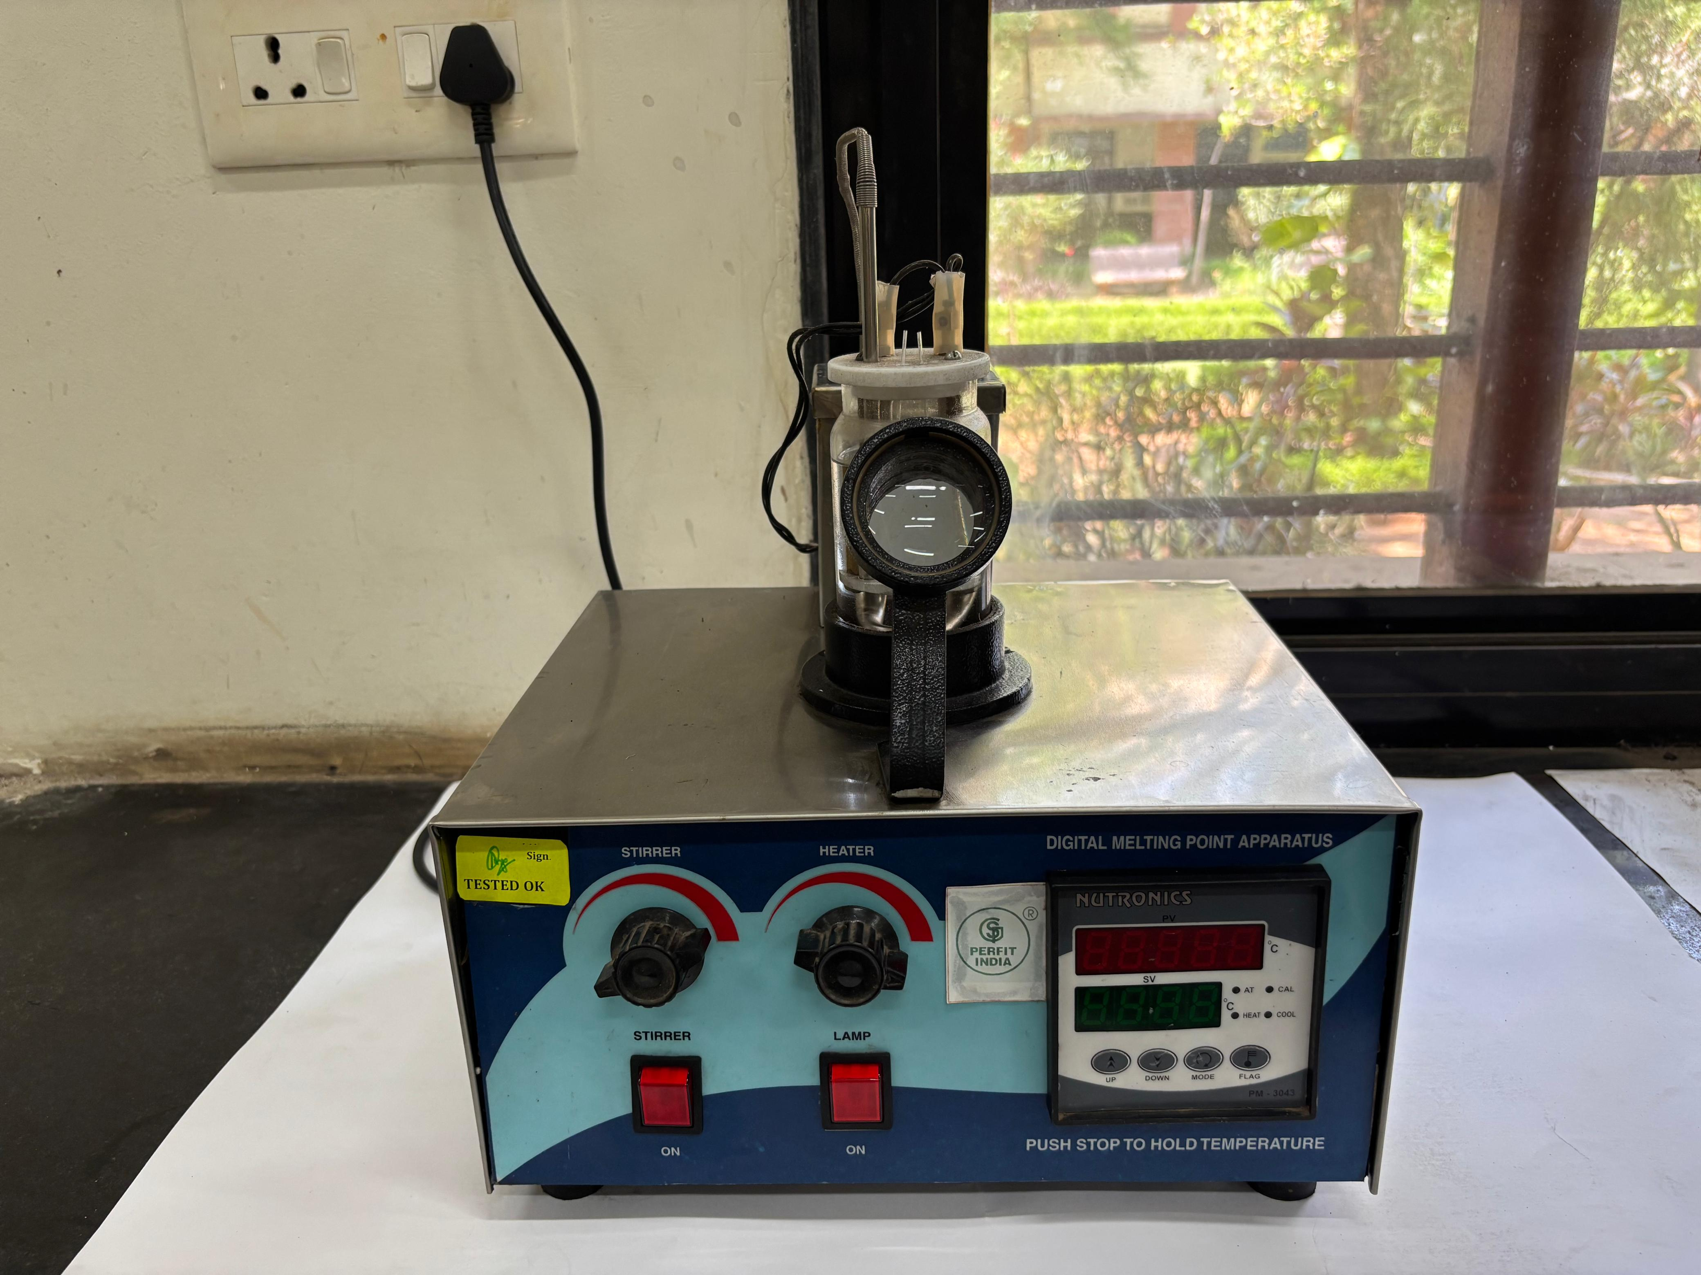 | Yes
Flame Photometer | 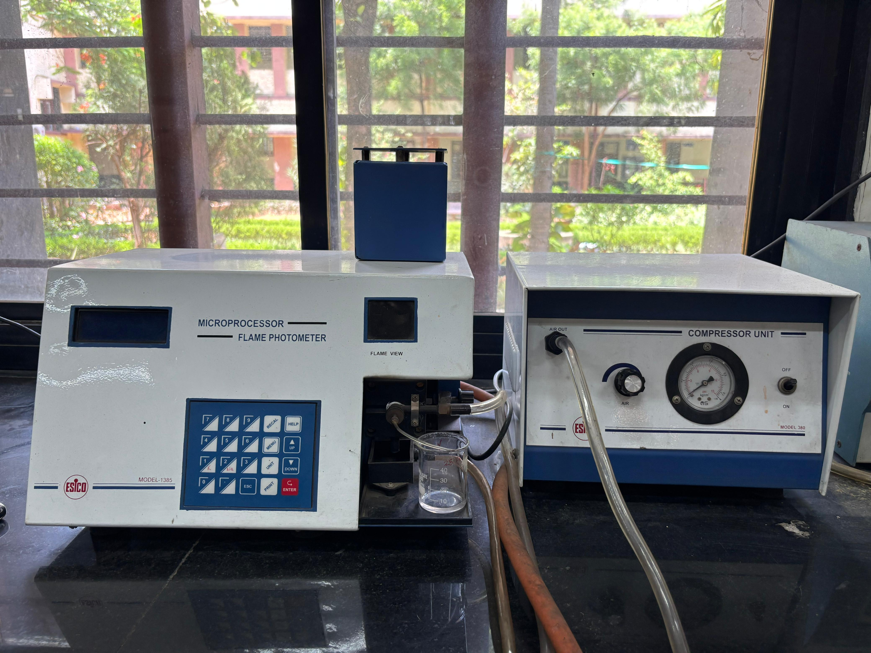 | Yes
Computer Lab | 5 computers | Yes

Equipment Available in Research Laboratory
Name of Equipment | Photo | Is Working?
UV-VIS Spectrophotometer | 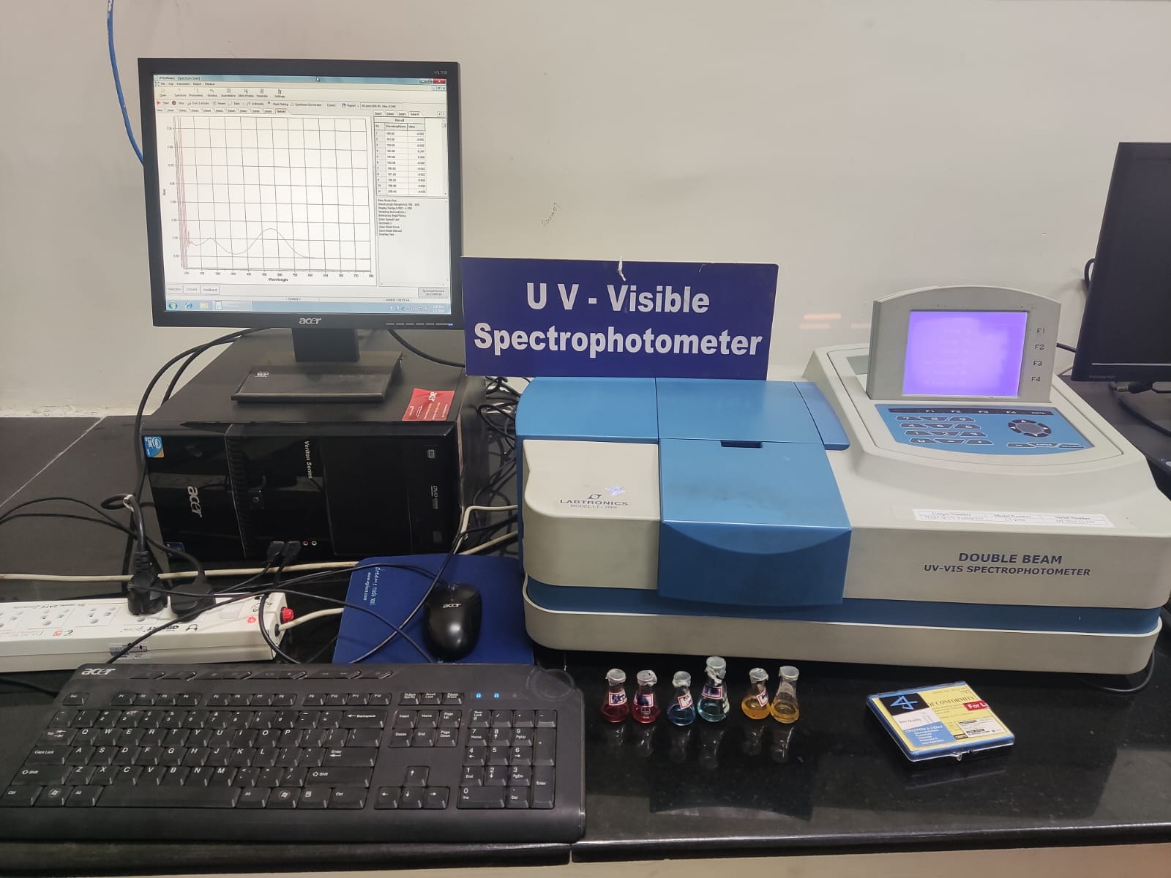 | Yes
Atomic Absorption Spectrophotometer | 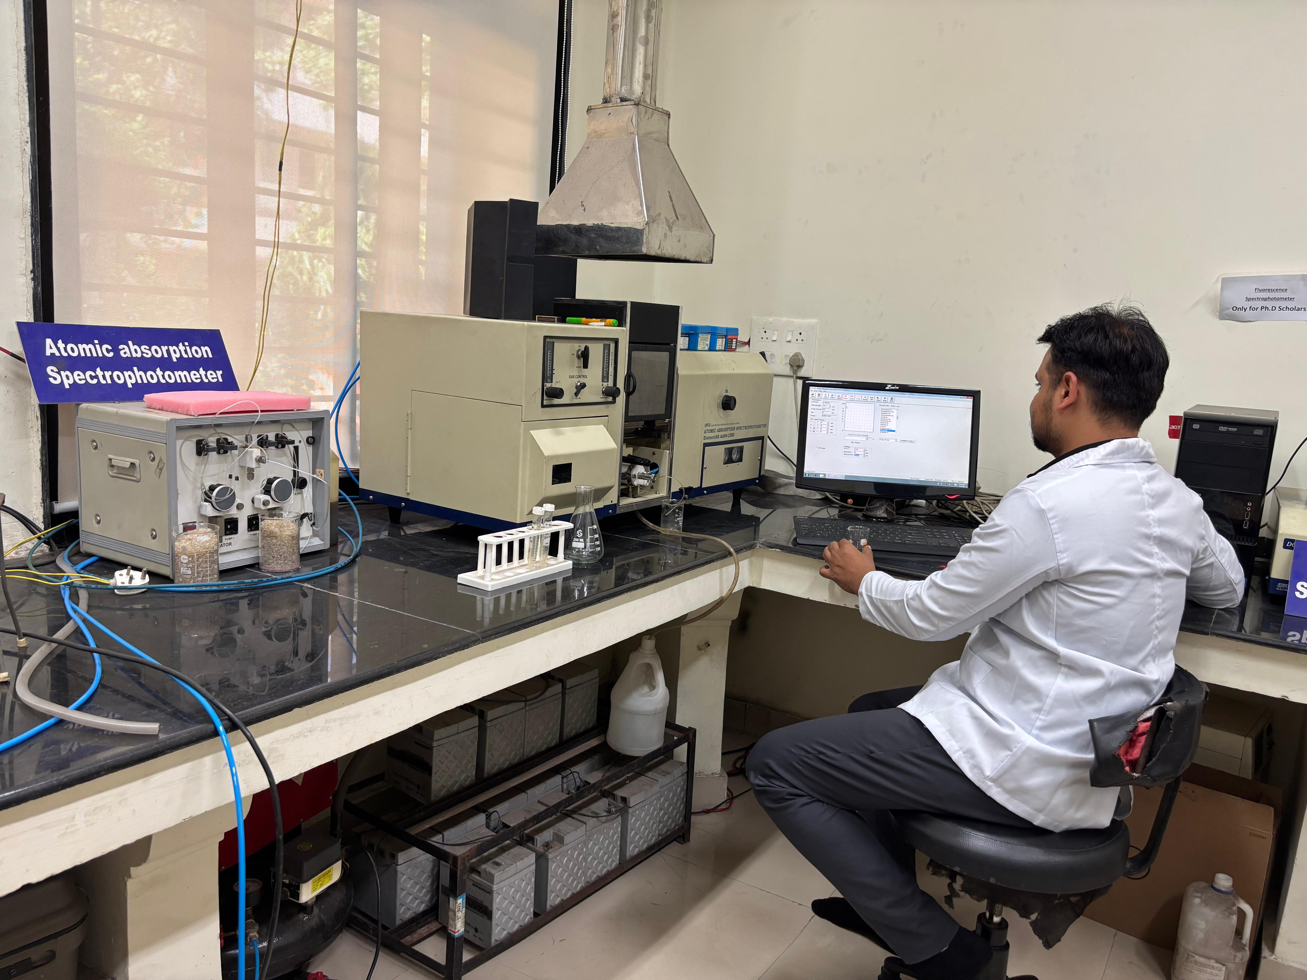 | Yes
Fluorescence Spectrophotometer | 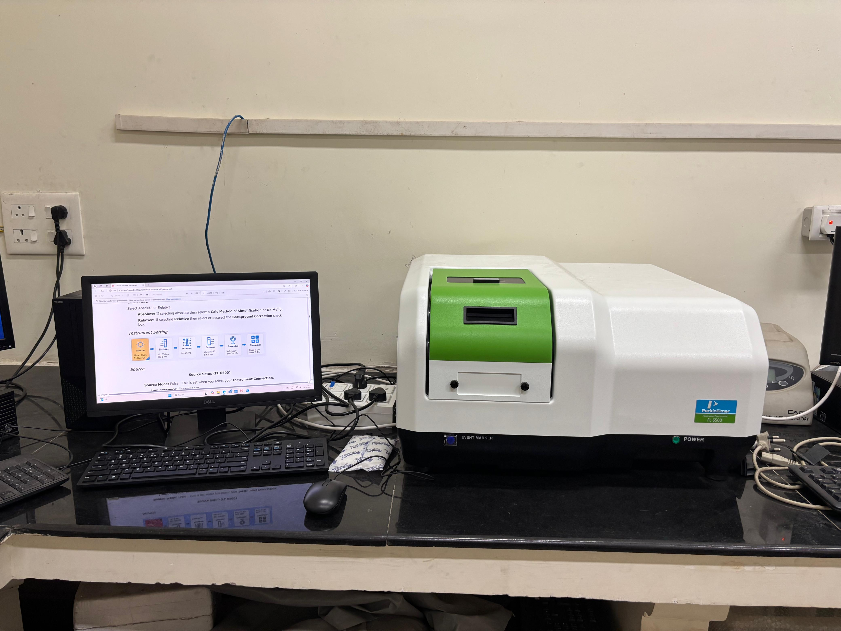
Potentiostat/Galvanostat | 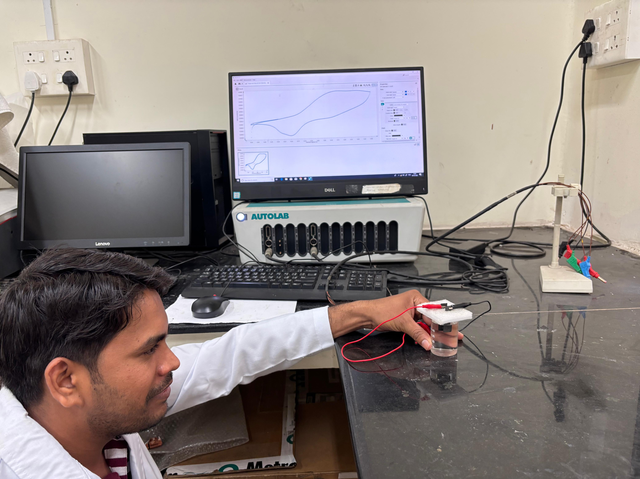 | Yes
Rheometer | 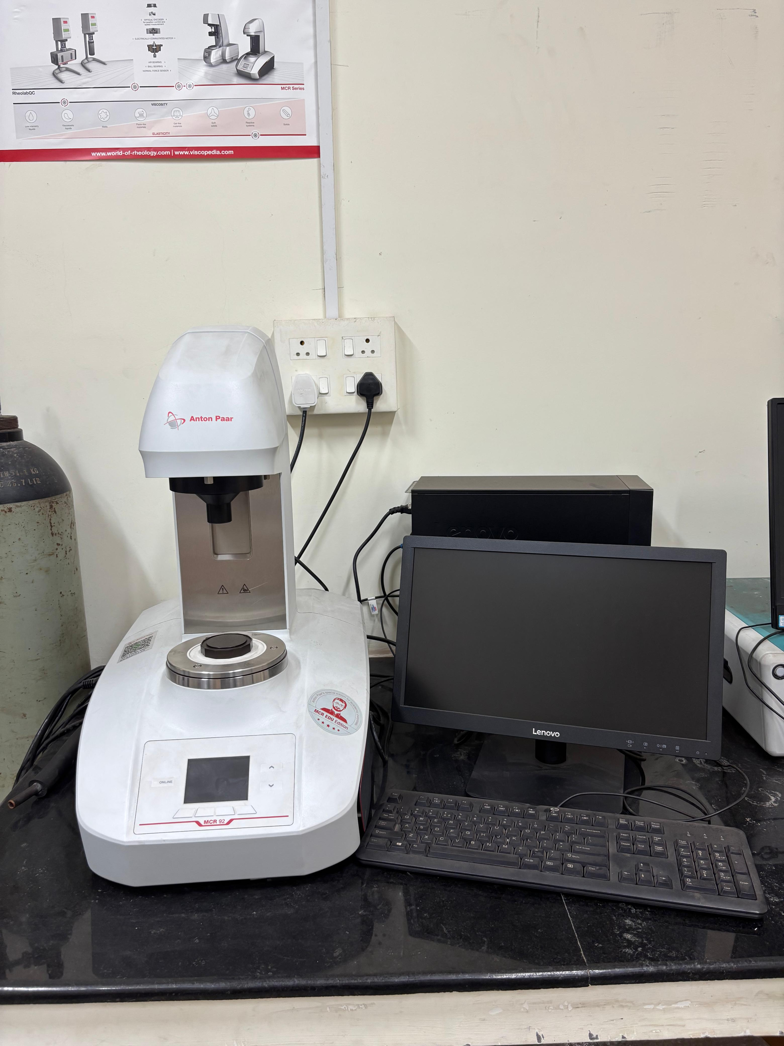 | Yes
Millipore Water Purifier | 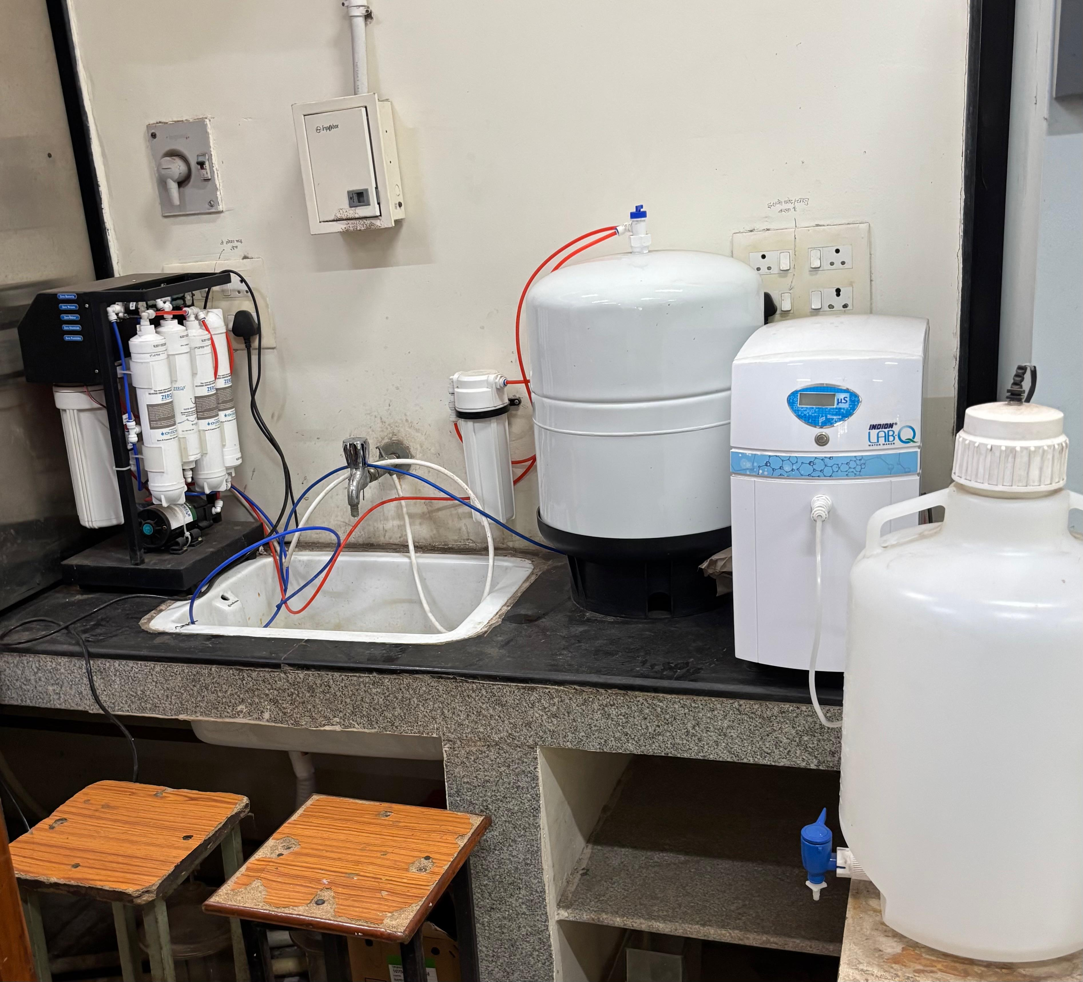 | Yes

