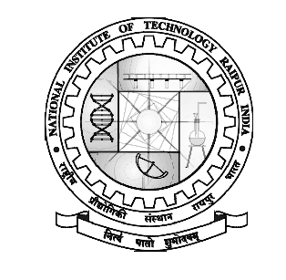
jk"Vªh; ÁkS|ksfxdh laLFkku jk;iqj
NATIONAL INSTITUTE OF TECHNOLOGY RAIPUR
(An Institute of National Importance)
G.E. Road, Raipur – 492010 (CG)
Phone: (0771) 2252700
Email: registrar@nitrr.ac.in
Website: www.nitrr.ac.in

No./NITRR/Estt. Gaz/Advt./2017/1388 Raipur, Dated- 05/09/2017
Walk-In-Interview

Walk-in-interview will be conducted for the Temporary Post of Technical Assistant for Virtual Classrooms over National Knowledge Network (NKN) at National Institute of Technology, Raipur on 18.09.2017 at 11:00 am.

Minimum Qualification: 3 years regular Engineering Diploma in ECE/Computer Engineering/IT, preferably 2 years relevant experience.
Desirable: Hardware maintenance and software administration exposure for multimedia equipment. The candidate will be required to handle basic office automation procedures and should have basic knowledge of the networked equipment.
Salary: Rs. 15000/- p.m. consolidated per month for the duration of the project.
Interested candidates may appear for the interview along with all original and attested copies of certificates. The candidates are to report at 11:00 a.m. on the above date in the Institute for verification of documents.

Candidates are informed; the recruitment is purely on contract basis for a period of 06 months that may be extended for another 06 month according to performance of the candidate.
–Sd-
REGISTRAR

