**National Conference**

**on**

**“Recent Trends and Advancement in Power Electronics, Electrical Drives and Control”**

**8th& 9thFebruary, 2020**

**REGISTRATION FORM**

Name: ………………………………………….

Designation: …………………..………………..

Organization: …………………………………..

Qualification: …………………………………..

Gender:…………………………………………

Correspondence Address: ………….…………..

……………………………………....................

Tel. (O) ………………. (R) …..……….............

(M) …………………………….…….............

Fax. No.…………………………..…….............

E-Mail: ………………………..………………..

Registration Fee: Paid herewith in the form of DD/ Banker’s cheque/Cash

Amount ……………….......................................

No...............................Date …………………….

Name of the Bank……………………..………..

Accommodation Required: Yes / No

Signature

Date: Place:

Note:

* *Demand draft/ Banker’s Cheque should be in favour of Director, National Institute of Technology Raipur, payable atSBI Brach, GCET Raipur. Cash should be deposited to organizing secretary(s) on or before the last date of registration.*
* *Photocopy of registration form may be used.*

**National Conference**

**on**

***Recent Trends and Advancement in Power Electronics, Electrical Drives and Control***

**8th& 9thFebruary, 2020**

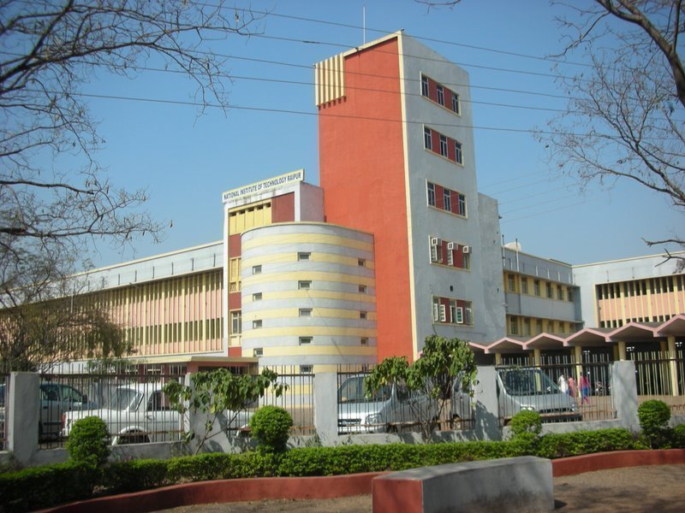

***Organized by***

**Department of Electrical Engineering**

**National Institute of Technology**

**Raipur-492 010 (Chhattisgarh)**

**Chief Patron**

Dr. A. M. Rawani, Director, NIT Raipur

**Patron**

Dr. S. Gupta, Dean (R&C), NIT Raipur

**Chairman**

Dr. N D Londhe

HoD, Department of Electrical Engineering

**Organizing Secretary(s)**

Dr. Sachin Jain

Dr. Lalit Kumar Sahu

**Organizing Committee Members**

Dr. P. D. Dewangan, NIT Raipur.

Dr. S. Patnaik, NIT Raipur.

Dr. N. D. Londhe, NIT Raipur.

Dr. Anamika Yadav, NIT Raipur.

Dr. R N Patel, NIT Raipur.

Dr. Varsha Singh, NIT Raipur.

Dr. Ebha Koley, NIT Raipur.

Dr. Monalisa Biswal, NIT Raipur.

Dr. Binod Shaw; NIT Raipur.

Dr. K. Chandrashekharan, NIT Raipur.

Dr. Baidynath Bag, NIT Raipur.

**Address for Correspondence**

Dr. Sachin Jain

*Associate Professor*

*Department of Electrical Engineering*

*NIT Raipur (CG) - 492 010*

Contact No.: +91-9441700975

E-mail: sjain.ee@nitrr.ac.in

Dr. Lalit Kumar Sahu

*Assistant Professor,*

*Department of Electrical Engineering,*

*NIT Raipur (CG) - 492 010*

Contact No.: +91-9752314242

E-mail: lkumar.ele@nitrr.ac.in.



***About the Institute:***

**National Institute of Technology Raipur** (Formerly Government Engineering College Raipur), situated in the capital of a newly incepted state of Chhattisgarh, has proven to be "advent-grade’’ in the field of science and technology over past few decades in this region. With sweet memory of foundation ceremony by our president Honorable Dr. Rajendra Prasad on 14th September 1956, the institute started with two departments namely Metallurgical and Mining Engineering. Later the inauguration of the Institute building was done by our Prime Minister Honorable Pt. Jawaharlal Nehru on 14th March 1963. From 1st December 2005, the institute has become the National Institute of Technology. It is well connected with Mumbai, Delhi, Hyderabad, Kolkata, Bhopal, Ahmadabad, Bangalore, Chennai and Chandigarh by regular flights and is on the main Howrah-Mumbai railway route. The institute is 5 km from the Raipur railways station and 18 km from airport on NH-6, the Great Eastern Road.

***About Department:***

The Department of Electrical Engineering came into existence in 1958. Department of Electrical Engineering aims at imparting the state of the art knowledge and skills to the students in the field of electrical engineering and to mould them to become successful intellectuals of the society. The department provides an outstanding research environment and offers academic program leading to the award of B.Tech, M.Tech and Ph.D. degree..

**Objective of Conference:**

The objective of the conference on Recent Trends and Advancement in Power Electronics, Electrical Drives and Control is to bring the researchers from all the esteemed institutes National wide. Along with researchers, this conference brings a scope to interact with the professionals and executives from energy sector, manufacturing industries, electrical power companies this helps in sharing the ideas and information pertaining to recent development in the area of Power Electronics, Drive and Control.

***Targeted Participants:***

* Academicians
* Industry Professionals
* Students and Research Scholars

***Registration Fee Details (in INR):***

|  |  |
| --- | --- |
| **Participants** | **Amount (in Rs)** |
| Students/ Research Scholar | 1000 |
| Faculty | 2000 |
| Industry Delegates | 3000 |

Applications in prescribed format with registration fee in the form of Cash/ Demand Draft/ Banker’s Cheque in favour of “***Director, NIT Raipur***”*payable at SBI Brach, GCET Raipur* must reach the Organizing Secretary(s) on or before the last date of Registration. The registration fee includes a registration kit, a single paper presentation/publication, Lunch and Tea/High-tea, Entry in all the session(s). Incomplete or registration form without cash/ demand draft/fee will be rejected. A separate registration form should be used for every delegate. Registration fee is non-refundable. No TA/DA will be paid to the participants.

***Accommodation:***

The participants may be provided accommodation in the institute guest house and/or hostel depending on the availability, on the payment basis. Accommodation can also be booked in nearby hotels directly by the participants by their own.

***The Best Paper Presentation Award:***

The award will be presented for the best paper(s) presentation during the conference. A Cash Prize and Certificate of Merit shall be awarded to the winner(s).

***About the Conference:***

Recent Trends and Advancement in Power Electronics, Electrical Drives and Control is a new conference, which is organized by Department of Electrical Engineering sponsored by NIT, Raipur. The Conference focuses and targets mainly on the areas of the Power Electronic Converters, MLI Topologies, Fault Tolerant Operation to Converters and control systems, Smart Grid Technology, Renewable energy Resources, Electric vehicles, Energy storage & battery charging techniques, Battery Management Systems, Microgrid & Smart grid, Energy policies & Standards, Wide band gap devices, Lighting Technology, Power electronic education.

**Conference Theme:**

* Power Electronics Converters Topology
* Control of Power Electronic Converters
* Electrical Drives
* Electric and Hybrid electric vehicles
* Electric Vehicle Charging Station
* LED Drivers
* Solar Photovoltaic Application
* Smart Grid and Microgrid
* ICT in Power Electronics
* Power Electronic in Renewable energy System
* Power Electronic in Hybrid Energy System
* Fault Detection and Diagnosis of PEC
* Fault Tolerant Operation of PEC
* PWM Techniques
* Wide band gap devices
* Grid Tied Converters
* Transformerless Converters
* High Frequency Converters
* IoT in Power Electronics

***Abstract Submission:***

Abstract should be submitted through email to the mail id: [*rtpec.rtc@gmail.com*](mailto:rtpec.rtc@gmail.com) on or before 15th January, 2020. Acceptance of the abstract will be decided by the review committee after a peer review process and notified within three days of submission. Last date for registration is 1st February ,2020.